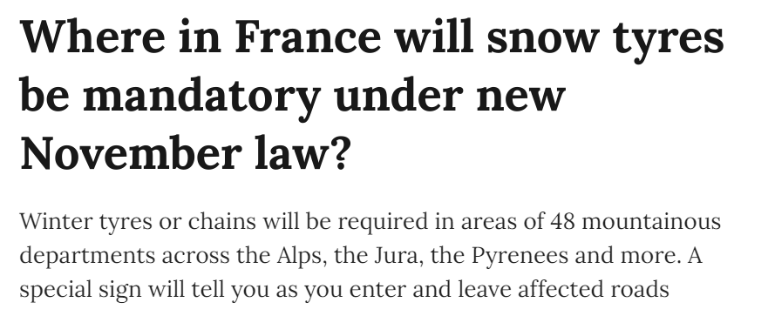
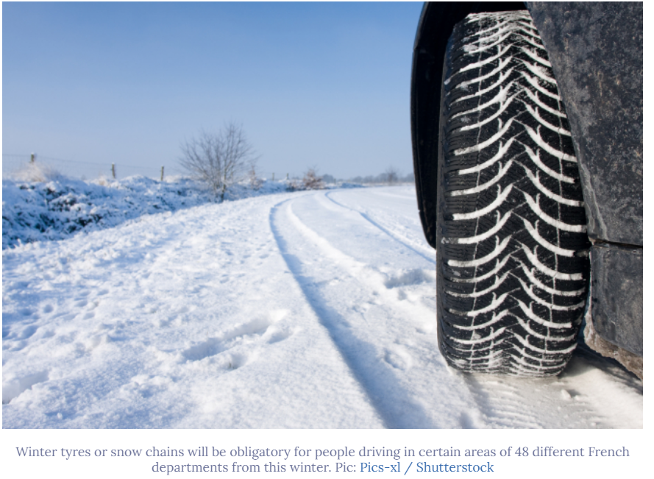

Reader question: Where in France will you be required to fit your car with snow tyres this winter?
All drivers travelling through certain areas of 48 French departments will from this year be obliged to fit their vehicles with winter tyres or snow chains under a law which comes into force on November 1.
Until this date, snow chains are only required on roads with B26 signs reading “équipements spéciaux obligatoires” (special equipment is compulsory) for snowy weather.
The new winter modification rules are detailed under the 2016 Loi Montagne 2 (“Mountain Law 2”), which has altered the highway code.
Vehicles such as cars, camper vans and vans can either use four winter tyres or, failing this, carry fabric or metal snow chains for at least two driving wheels in their boot.
So, if you only visit the mountains occasionally you can avoid buying four new tyres as long as you have chains.
Drivers will need to have to use winter tyres or chains between November 1 and March 31.
Read more: New winter tyre rules take effect on some French roads from November
The departments affected include:
- Ain
- Allier
- Alpes-de-Haute-Provence
- Hautes-Alpes
- Alpes-Maritimes
- Ardèche
- Ariège
- Aude
- Aveyron
- Cantal
- Côte-d'Or
- Creuse
- Doubs
- Drôme
- Eure-et-Loir
- Gard
- Haute-Garonne
- Hérault
- Isère
- Jura
- Loire
- Haute-Loire
- Lot
- Lozère
- Meurthe-et-Moselle
- Moselle
- Nièvre
- Puy-de-Dôme
- Pyrénées-Atlantiques
- Hautes-Pyrénées
- Pyrénées-Orientales
- Bas-Rhin
- Haut-Rhin
- Rhône
- Haute-Saône
- Saône-et-Loire
- Savoie
- Haute-Savoie
- Tarn
- Tarn-et-Garonne
- Var
- Vaucluse
- Haute-Vienne
- Vosges
- Yonne
- le Territoire de Belfort
- Corse du Sud
- Haute-Corse
The Loi Montagne 2 states that: “The prefects of 48 departments situated in the mountains, whether in the Alps, Corsica, the Massif Central, the Jura, the Pyrenees or the Vosges Massif, must set out a list of the towns in which vehicles should be appropriately equipped for the winter.”Drivers entering an area where winter tyres or chains are required will be warned by a B58 sign bearing an image of a mountain and of two properly equipped tyres.
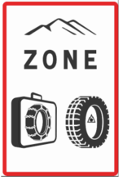
A B58 sign signalling entry in
to a winter tyre zone| Photo: Sécurité routière
On leaving the affected area, they will see a B59 sign reading ‘fin de zone’ and showing a line crossing out the mountain and tyre icons.

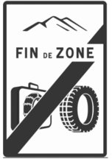

A B59 sign signalling exit from a winter tyre zone | Photo: Sécurité routière
Cars with studded tyres do not need to be fitted with winter tyres.
Coaches, buses and HGVs without trailers must also install winter tyres or chains, while HGVs with trailers must have chains on at least two of their driving wheels, even if they are also equipped with winter tyres.
Those who ignore the winter tyre requirement could face a fine of €135, and may not be allowed to continue driving their vehicle.

